Chapter 2, Solution 29

All resistors in Fig. 2.93 are 5 Ω each. Find R_{eq}.

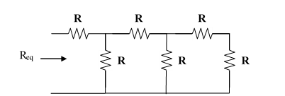

Figure 2.93
For Prob. 2.29.

Solution

R_{eq} = 5 + 5||[5+5||(5+5)] = 5 + 5||[5+(5x10/(5+10))] = 5+5||(5+3.333) = 5 + 41.66/13.333

= 8.125 Ω

